DAILY ONLINE ACTIVITIES SUMMARY

|  |  |  |  |  |  |  |  |
| --- | --- | --- | --- | --- | --- | --- | --- |
| **Date:** | **20-05-2020** | | | | **Name:** | **Sathvik R Shetty** | |
| **Sem & Sec** | **VI B** | | | | **USN:** | **4AL17CS089** | |
| Online Test Summary | | | | | | | |
| **Subject** | | **SSCD IA Test** | | | | | |
| **Max. Marks** | | **30** | | **Score** | | **21** | |
| Certification Course Summary | | | | | | | |
| **Course** | **Web Development with Python and Javascript** | | | | | | |
| **Certificate Provider** | | | **Harvard University** | **Duration** | | | **12weeks** |
| Coding Challenges | | | | | | | |
| **Problem Statement:**   1. Python Program to Execute the Values of Two Number using ^ (exclusive or operator). 2. Write Python Program to Reverse a Given Number. This is a Python Program to reverse a given number. | | | | | | | |
| **Status:Completed** | | | | | | | |
| **Uploaded the report in Github** | | | | **Yes** | | | |
| **If yes Repository name** | | | | [https://github.com/sathvikshetty22/Online-](https://github.com/sathvikshetty22/Online-Coding) [Coding](https://github.com/sathvikshetty22/Online-Coding) | | | |
| **Uploaded the report in slack** | | | | **Yes** | | | |

Online test Detail:

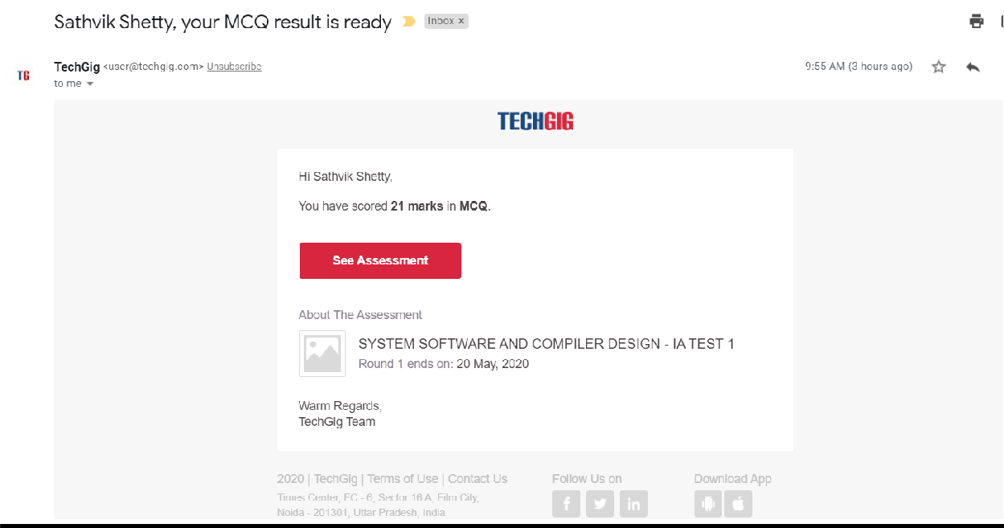

Online Certification Details

**Lesson-3**

* Flask

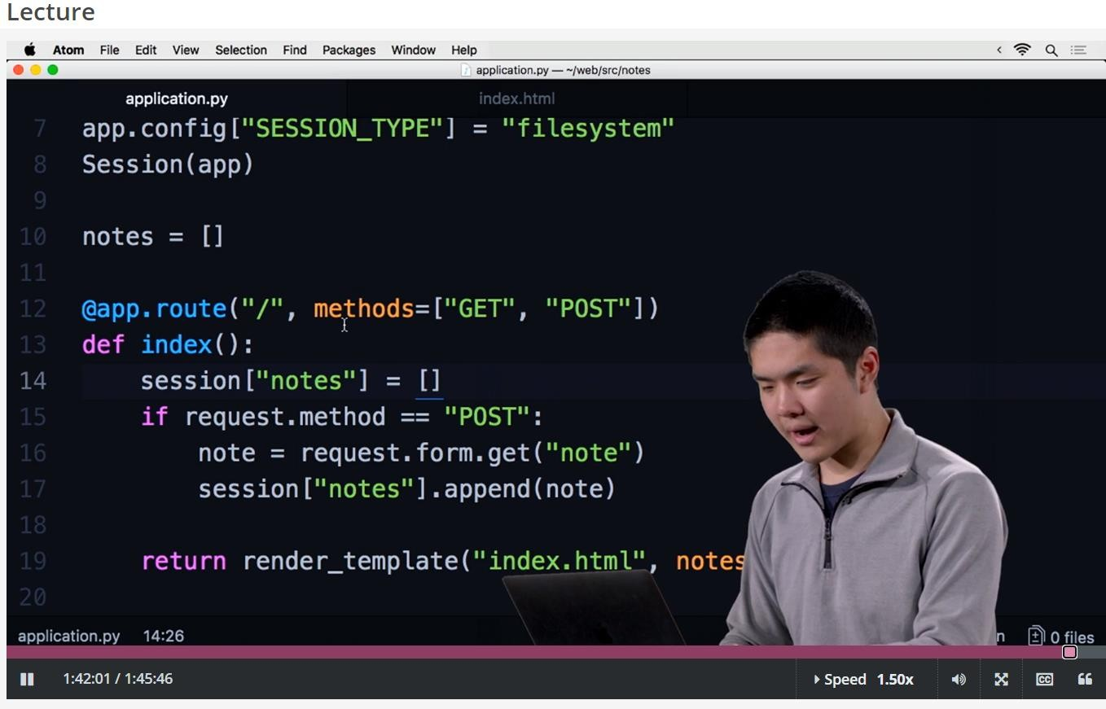

Coding Challenge Details

1. Python Program to Execute the Values of Two Number using ^ (exclusive or operator)

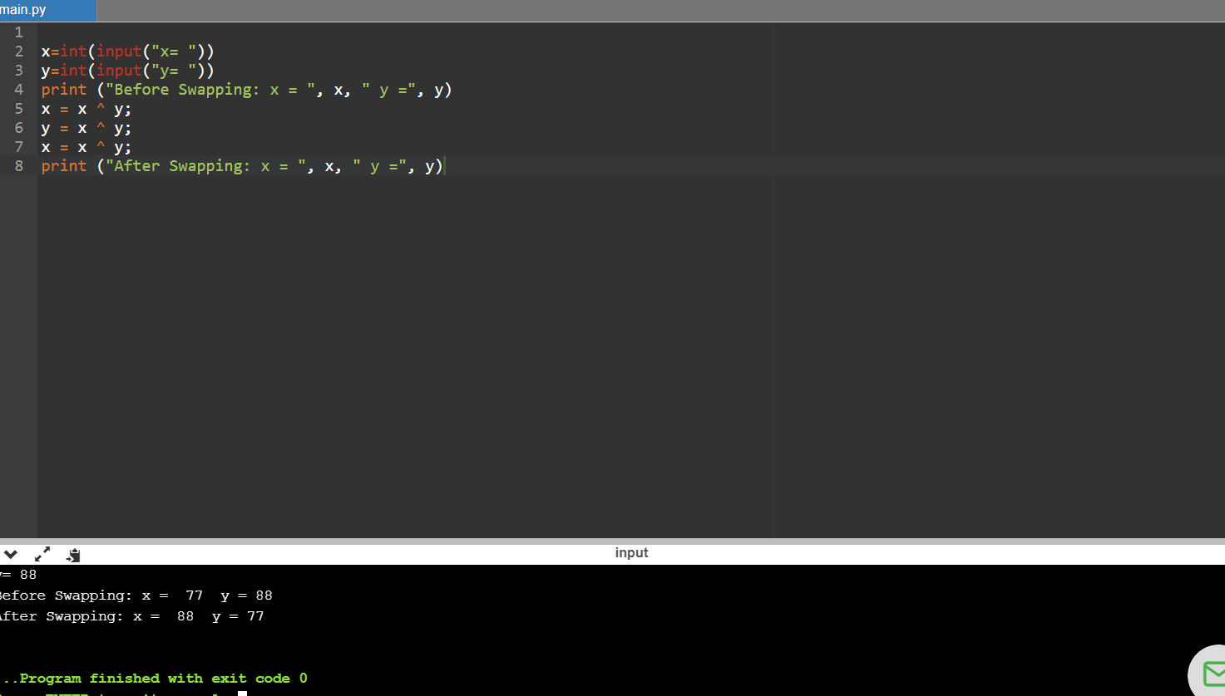

1. 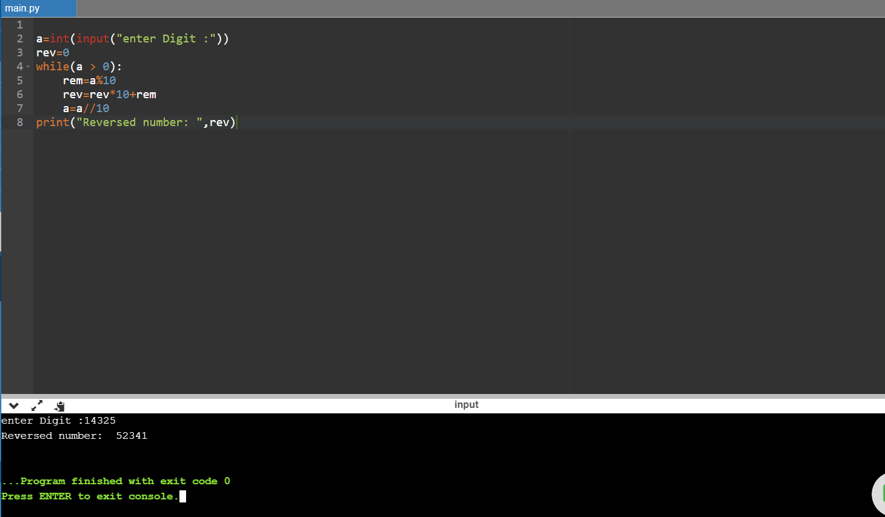Write Python Program to Reverse a Given Number. This is a Python Program to reverse a given number.